**Week 1: Introduction to Networking & Network Security**

**Objective:** Understand basic network components, models, and security principles.

**Task # 03: Use ipconfig (Windows) or ifconfig (Linux) to view your device’s network configurations and take a screenshot.**

**Solution:**

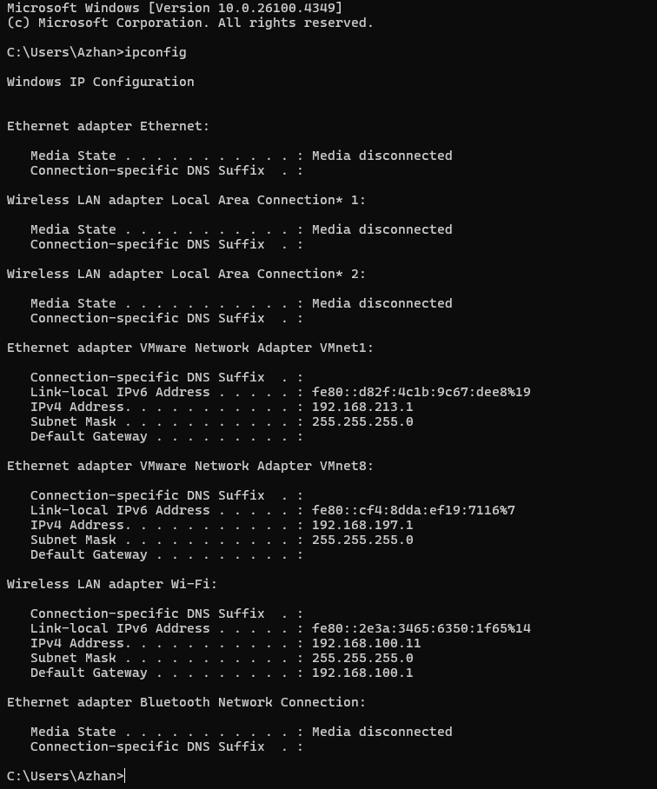

This output details the network configurations for various adapters present on the device, including:

* Several "Media disconnected" adapters (Ethernet, Wireless LAN adapters) indicating no active connection.
* **VMware Network Adapters (VMnet1 and VMnet8):** These show active virtual network connections with assigned IPv4 and Link-local IPv6 addresses, subnet masks, and default gateways. For instance, VMnet1 has an IPv4 Address of 192.168.213.1.
* **Wireless LAN adapter Wi-Fi:** This adapter is active and shows an IPv4 Address of 192.168.100.11, a Subnet Mask of 255.255.255.0, and a Default Gateway of 192.168.100.1. It also has a Link-local IPv6 Address.
* **Bluetooth Network Connection:** This adapter is currently disconnected.